Year 3/4 Long Term Overview Year A
Persuade Inform Entertain Discuss
Autumn 1 | Autumn 2 | Spring 1 | Spring 2 | Summer 1 | Summer 2
Learning Journey 1 | Learning Journey 1 | Learning Journey 1 | Learning Journey 1 | Learning Journey 1 | Learning Journey 1
Text: Journey, Aaron Becker  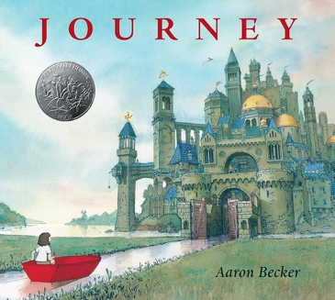  Outcomes:  Setting Description  Narrative retelling  Expanded noun phrases  Prepositions  Fronted adverbials | Text: Princess who hid in the tree  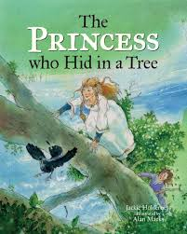  SOA: Writing a letter  Outcome:  Diary- focus on feelings not telling a story  Tenses  Verb endings  conjunctions  Daily dictations | Text: Until I met Dudley  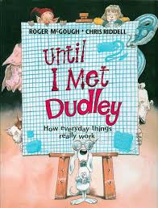  SOA:  Letter to Dudley  Outcome:  Explanation text/instructional writing  Time Adverbials  Conjunctions  Sequencing in Order | Text: How the Whale Became, Ted Hughes  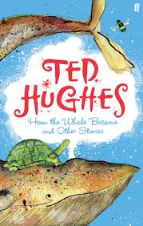  SOA:  Newspaper report  Outcome:  Write an origin story  Paragraph – TiPToP  Tenses | Text: River Stories  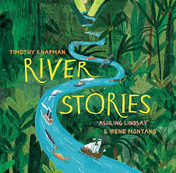  SOA: write a factual postcard/recount about visiting the River Nile  Outcome:  non-chronological report (re-create a river stories style page from a river of their choice or imaginary river)  Subheadings  Technical vocabulary | Text:  The Abominables  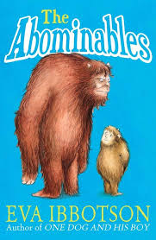  Outcome:  Write multiple outcomes to consolidate learning for UKS2  Setting description  Letter  Diary  Guide book/ Non chron report
Learning Journey 2 | Learning Journey 2 | Learning Journey 2 | Learning Journey 2 | Learning Journey 2
Text: The Promise, Nicola Davies  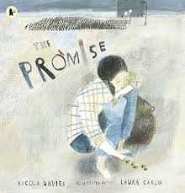  SOA:  First person narrative retelling  Outcome:  Letter  Subordination and varying sentence structures | Text:  The Nutcracker  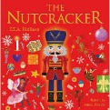  SOA: writing a diary  Outcome:  Setting description to accompany a picture from the book  Determiners  ISPACE fronted adverbials | Text:  Charlotte’s Web  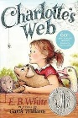  SOA: Explanation Text  Outcome:  Newspaper report at the fair  dialogue | Text:  The story of Tutankhamun  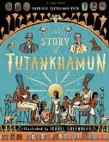  SOA: diary  Outcome:  Biography about Howard Carter (archaeologist)  Possessive apostrophes  Time Adverbials/Conjunctions | Text: Jaberwocky  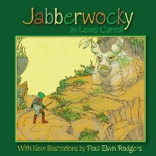  Outcome: Poetry  Analyse a range of poems and structures
Guided reading  Warewolf club rules – poetry | Guided reading  Butterfly Lion | Guided reading  Charlotte’s Web | Guided reading  The Humans | Guided reading  Water Horse | Guided reading  The Abominables

